Charge Back Calculation
Use Case Document


 | Prepared By / Last Updated By | Reviewed by | Approved By
Name | Rahul Kumar | Sarthak Shukla | Ashu Jauhari
Role | Team Member | Team Member | Scrum Master
Signature | Rahul Kumar
Date | 4/10/2019

Table of Contents
1.0 Introduction 4
1.1 Purpose & Scope of the document 4
1.2 Intended Audience 4
1.3 Use case ‘User Registration’ 4
1.3.1 Use case attributes 4
1.3.2 Use Case Model 5
1.3.3 Business Rules 5
1.3.4 UI Requirements 6
1.3.5 UI Field Validations 7
1.4 Use case ‘User Credential Authentication’ 7
1.4.1 Use case attributes 7
1.4.2 Use Case Model 8
1.4.3 Business Rules 8
1.5 Use case ‘Customer Details Post Login’ 9
1.5.1 Use case attributes 9
1.5.2 Use Case Model 10
1.5.3 Business Rules 10
1.5.4 UI Requirement 10
1.6 Use case ‘Capture Payments’ 11
1.6.1 Use case attributes 11
1.6.2 Use Case Model 12
1.6.3 Business Rules 12
1.6.4 UI Requirements 13
1.6.5 UI Field Validations 13
1.7 Use case ‘View Transactions’ 14
1.7.1 Use case attributes 14
1.7.2 Use Case Model 15
1.7.3 Business Rules 15
1.7.4 UI Requirements 16
1.8 Use case ‘Charge Back Details Page’ 17
1.8.1 Use case attributes 17
1.8.2 Use Case Model 18
1.8.3 Business Rules 18
1.8.4 UI Requirements 19
1.9 Use case ‘Edit Chargeback’ 19
1.9.1 Use case attributes 19
1.9.2 Use Case Model 21
1.9.3 Business Rules 21
1.9.4 UI Requirements 22
1.9.5 UI Field Validations 22
1.10 Use case ‘Refund for Chargeback’ 23
1.10.1 Use case attributes 23
1.10.2 Use Case Model 24
1.10.3 Business Rules 24
1.10.4 UI Requirements 25
1.10.5 UI Field Validations 25
1.11 Use case ‘Send Notification’ 26
1.11.1 Use case attributes 26
1.11.2 Use Case Model 27
1.11.3 Business Rules 27
2.0 Database Design 28
2.1 Tables Structure 28
3.0 Change Log 30

Introduction

Purpose & Scope of the document
The purpose of this Use case document is to systematically capture requirements for the project and the system to be developed in terms of use cases. Functional use cases are captured in this document. It also serves as the input for the project scoping.

The scope of this document is limited to addressing the use cases from a user, quality, and non-functional perspective.

Intended Audience
Each member of the project team

Use case ‘User Registration’

Use case attributes
Use Case Description:

This use case deals with the capture of Bank Representative user details. The ‘Bank Representative user’ here shall be the operator of the system and will be keying in the customers’ chargeback information into the system.

Scope:

- Bank Representative user registration

Actors:

- Bank Representative User – the operator

Trigger:

Click ‘Submit’ button in the ‘User Registration’ page

Pre-Condition:

User being able to access the homepage & get redirected to the ‘User Registration’ page upon click of ‘Register if new’ link.

Post Condition:

User is in the enrollment page & submit details

Flow of Events:

User at homepage → Click ‘Register if new’ link → User is in the enrollment page → User details are submitted and added onto the database

Primary Scenario:
A new user – is able to click ‘Register if new’ link and able to provide his details and get enrolled in the system.

Use Case Model
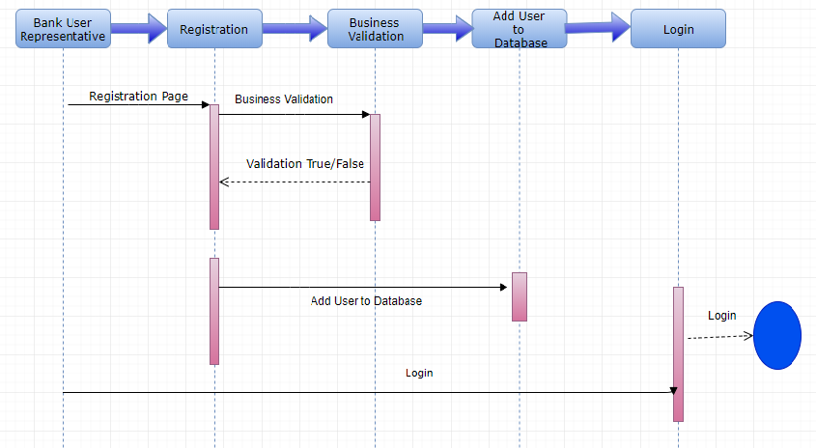

Business Rules

Business rules should be defined using the following attributes: -

- When the user clicks on the registration link, it should re-direct to registration form.
    - User needs to fill some of the basic attributes/fields as mentioned below in requirement: First Name, Last Name, Age, Gender, Contact Number, City, State, User Id, Password
- Clicking ‘Submit’ should validate the datatype constraints for each field
- Post-successful field level validation, save the information in the database
Upon saving the information in the database, display the message “New user created successfully”.

UI Requirements
Here is a prototype on how the homepage should look like.

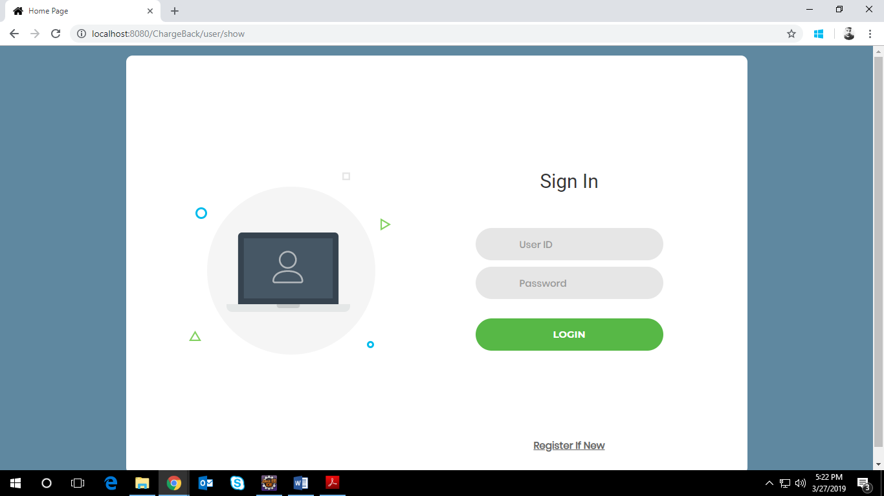

Here is a prototype on how the ‘User Registration’ page should look like.

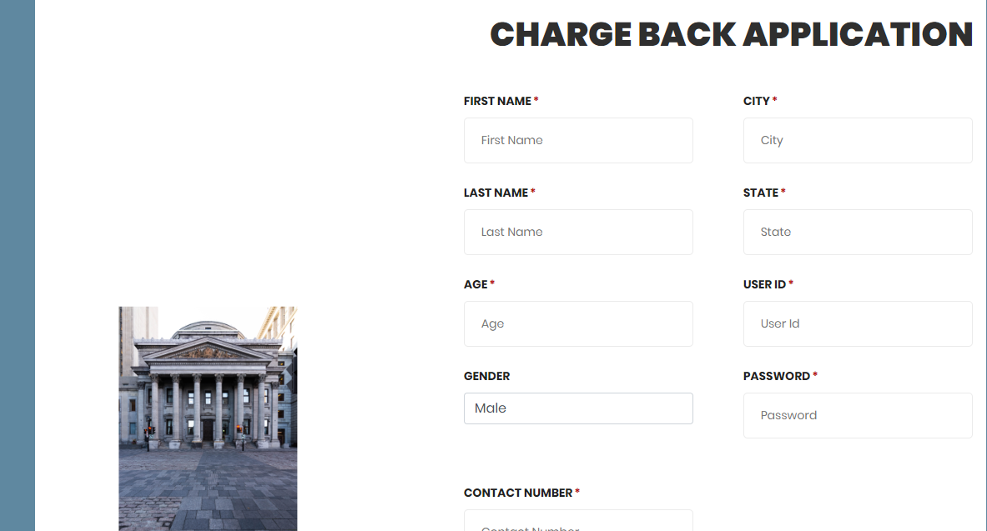

UI Field Validations
Please refer to the below requirements for field level validations:

- All fields are mandatory.
- Username should be less than 30 chars. Password should have minimum 8 chars, no space & can contain special characters (ex.! @,#,%,*,& etc.).
- Phone Number must be of 10 digits’ length.
- Invalid fields must be marked in red with alert message.

Use case ‘User Credential Authentication’

Use case attributes
Use Case Description:

This use case deals with the authentication of the user credentials. The ‘user’ here shall be the operator of the system

Scope:

- User credentials authentication

Actors:

Bank Representative User – the operator

Trigger:

Click ‘Login’ link, after keying in ‘User ID’ & ‘Password’ field.

Pre-Condition:

Bank Representative User being able to access the homepage

Post Condition:

Bank Representative User is in the Customers’ Details page

Flow of Events:

Bank Representative User at homepage → Key in ‘User ID’ & ‘Password’ field → User credentials are validated → Customers’ details page is displayed

Primary Scenario:
A registered Bank Representative user – is able click ‘Login’ link, after keying in ‘User ID’ & ‘Password’ field and get his credentials authenticated with the existing database entry.

Alternative Scenario:
A registered Bank Representative user – is able click ‘Login’ link, after keying in ‘User ID’ & ‘Password’ field and unable to get his credentials authenticated. The user is presented with relevant error messages:

- Invalid User ID – ‘The user ID provided does not exist in our records’
- Incorrect Password – ‘Password provided is incorrect. Please reach out to your system admin.’

Use Case Model
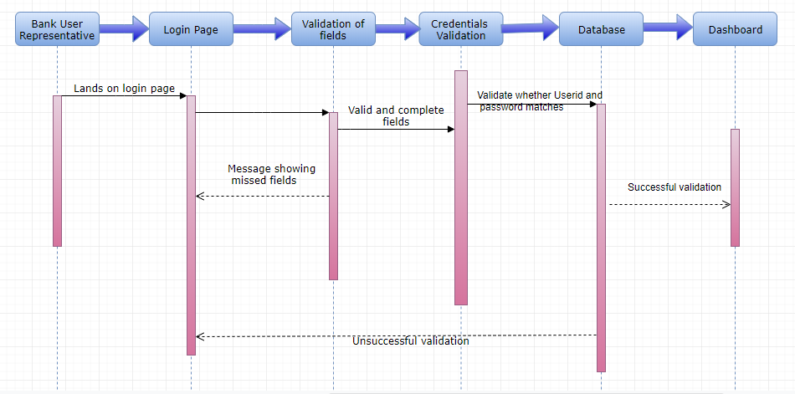

Business Rules
Business rules should be defined using the following attributes: -

- A registered Bank Representative user – is able click ‘Login’ link, after keying in ‘User ID’ & ‘Password’ field and get his credentials authenticated with the existing database entry

Use case ‘Customer Details Post Login’

Use case attributes
Use Case Description:

This use case deals with the page showing list of customers with their details. The ‘Bank Representative user ‘here shall be the operator of the system and is able to see list of account holders in bank referred as “Customer” in further document.

Scope:

- Dashboard (after login page) showing list of customers (account holders in bank).

Actors:

Bank Representative User – the operator

Trigger:

Click “Login” with correct user ID and Password

Pre-Condition:

Bank Representative User being able to access the homepage (login Page)

Post Condition:

Bank Representative User is in Login page for keying in correct user ID and password

Flow of Events:

Bank Representative User at homepage → Key in ‘User ID’ & ‘Password’ field → User credentials are validated → Customers’ details page is displayed

Primary Scenario:
A registered Bank Representative user – is able to login to system with correct user ID and password.

Alternative Scenario:
- A registered Bank Representative user – is able to see the customers’ list who are registered with details already present in database after successful login. The user is presented with relevant error messages on login page instead of landing on dashboard

Use Case Model
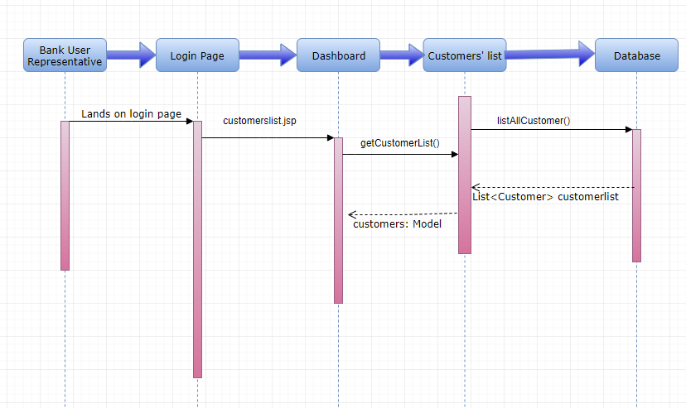

Business Rules
Business rules should be defined using the following attributes: -

- A registered Bank Representative user – is able to see the customers’ list who are registered with details already present in database after successful login.

UI Requirement
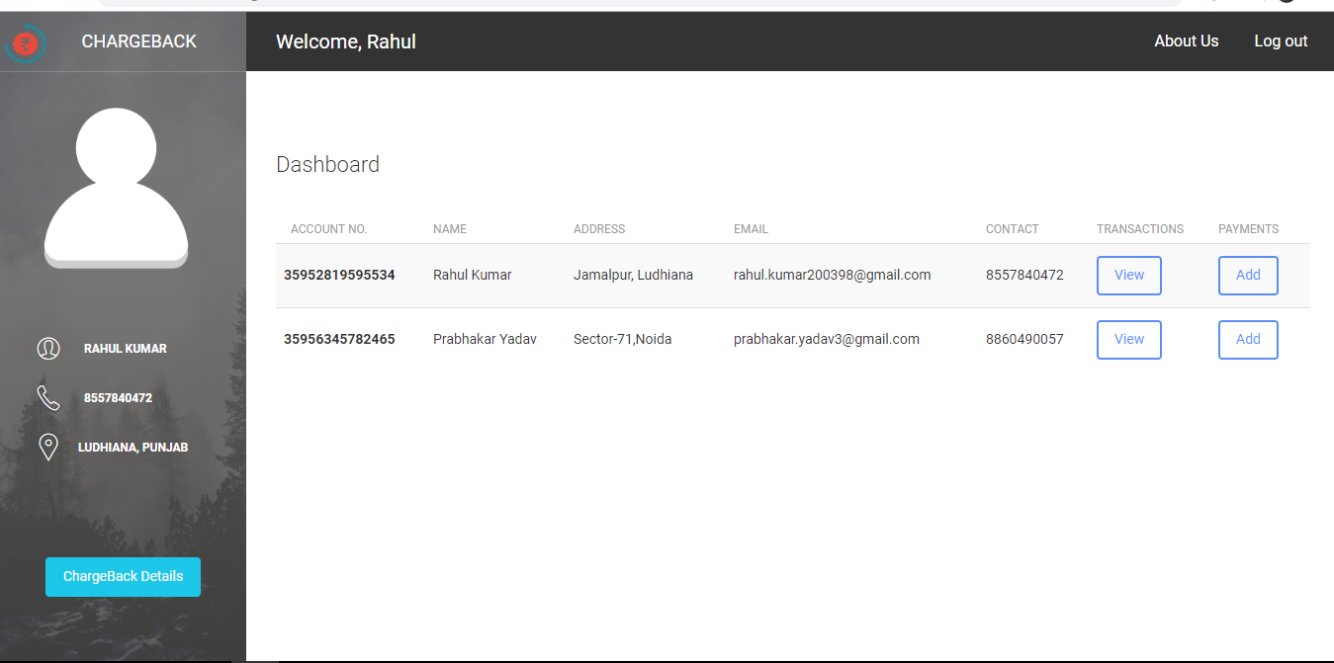

Use case ‘Capture Payments’

Use case attributes
Use Case Description:

This use case deals with the capture of payments details. The ‘Bank Representative user’ here shall be the operator of the system and will be keying in the payment information to the system.

Scope:

- Capture payment information to database

Actors:

- Bank Representative User – the operator

Trigger:

Click ‘Add Payment’ button in the ‘Dashboard’ page

Pre-Condition:

Bank Representative User being able to view ‘Dashboard’ page upon click of ‘Login’ button.

Post Condition:

Bank Representative User is in add payment page & submit payments details.

Flow of Events:

User at dashboard → Click ‘Add payments’ button → User is in add payment page → Payments details are submitted and added onto the database

Use Case Model
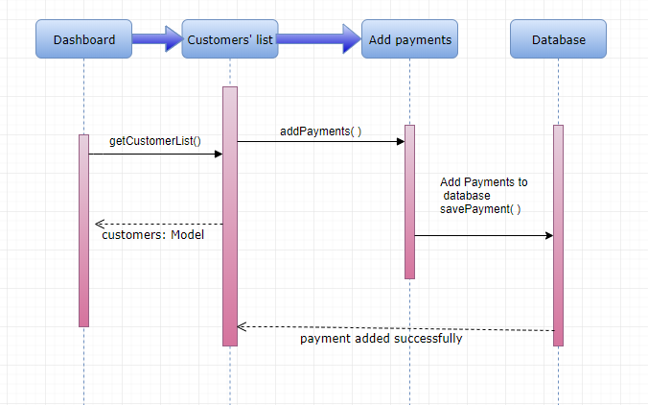

Business Rules

Business rules should be defined using the following attributes: -

- When the user clicks on the Add payment button, it should re-direct to Add payment form.
    - Bank Representative User needs to fill some of the basic attributes/fields as mentioned below in requirement: Transaction Amount, Transaction date, Dispute (if any), reason for the dispute.
- Clicking ‘Submit’ should validate the datatype constraints for each field
- Post-successful field level validation, save the information in the database

UI Requirements
Here is a prototype on how the homepage should look like.

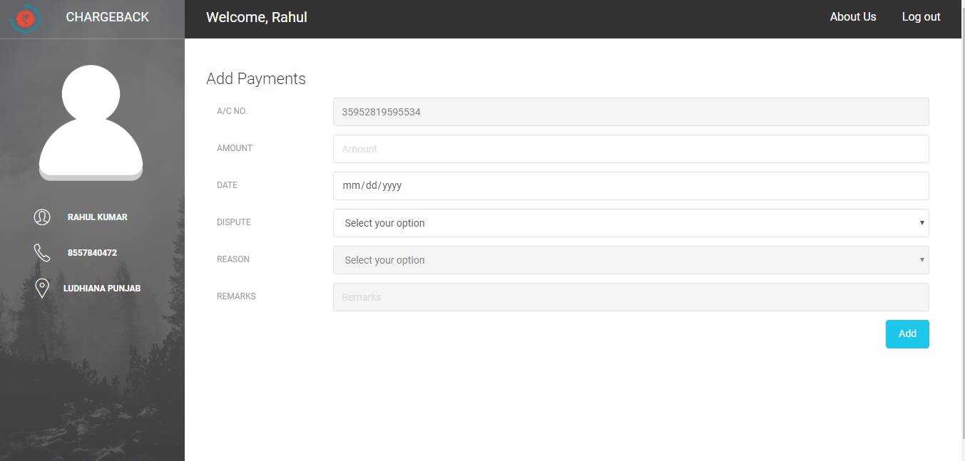

UI Field Validations
Please refer to the below requirements for field level validations:

- All fields are mandatory.
- Transaction Id is auto generated.
- Remarks mandatory if “Others” is chosen as reason attribute value.
- Invalid fields must be marked in red with alert message.

Use case ‘View Transactions’

Use case attributes
Use Case Description:

This use case deals with the page showing list of transactions with their details. The ‘Bank Representative user ‘here shall be the operator of the system and is able to see list of transactions of particular customers with its details.

Scope:

- View Transaction information from database

Actors:

- Bank Representative User – the operator

Trigger:

Click ‘View’ button in the ‘Dashboard’ page beside every customer details column.

Pre-Condition:

Bank Representative User being able to view ‘Dashboard’ page upon click of ‘Login’ button.

Post Condition:

Bank Representative User is in View Transactions page and can see the payments of particular customer with all details.

Flow of Events:

User at dashboard → Click ‘View’ button → User is in view payment page → Payments details are shown of particular customer.

Use Case Model
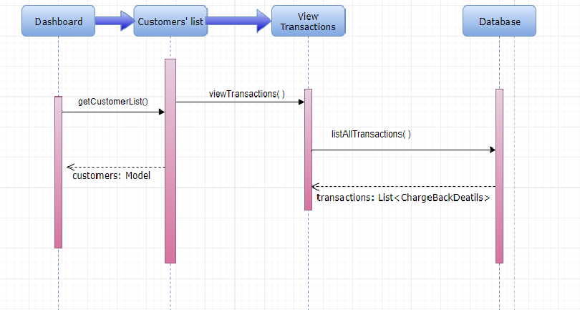

Business Rules

Business rules should be defined using the following attributes: -

- When the user clicks on the View button, it should re-direct to View payment page.
    - Bank Representative User view fields as mentioned below in requirement: Account Number, Transaction ID, Transaction Amount, Transaction date, Dispute (if any), reason for the dispute.

UI Requirements
Here is a prototype on how the homepage should look like.

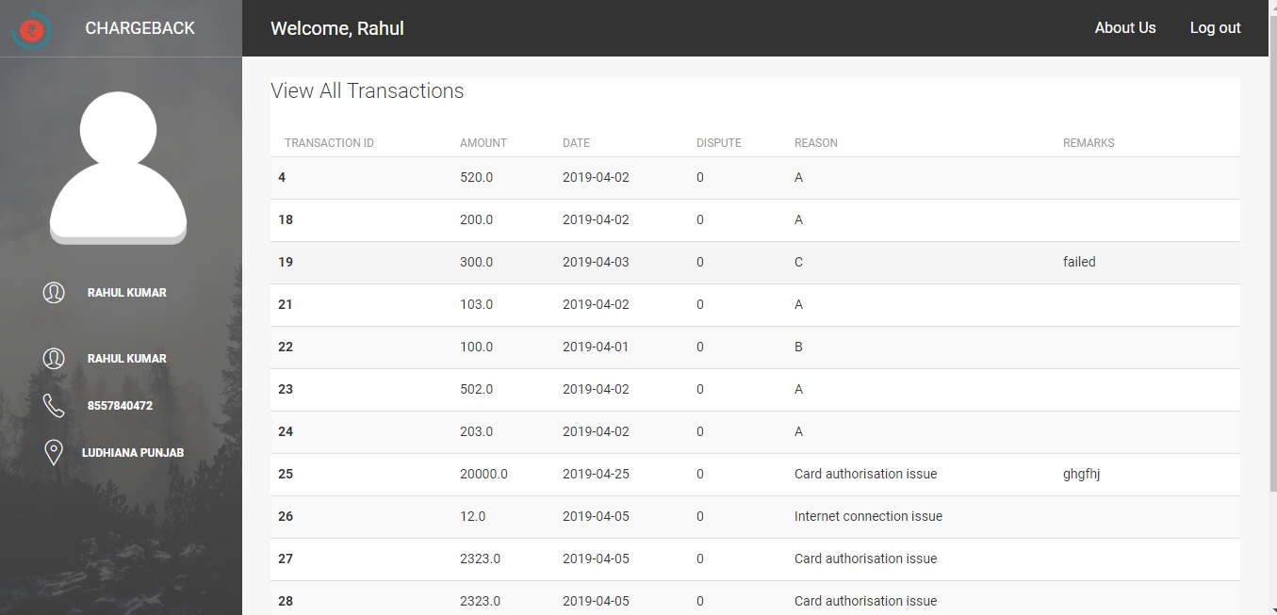

Use case ‘Charge Back Details Page’

Use case attributes
Use Case Description:

This use case deals with the page showing list of customers having chargeback applicable to their transactions with its details. The ‘Bank Representative user ‘here shall be the operator of the system and is able to see list of customers who have chargeback applicable to their transactions

Scope:

- Chargeback page showing list of customers (account holders in bank) with chargeback applicable.

Actors:

Bank Representative User – the operator

Trigger:

Click “Chargeback Details” button.

Pre-Condition:

Bank Representative User being able to access the dashboard.

Post Condition:

Bank Representative User is in Charge Back details page with list of customers with chargeback applicable.

Flow of Events:

Bank Representative User at dashboard→ Click on Charge Back Details button→ Customers’ Chargeback details page is displayed

Primary Scenario:
A registered Bank Representative user – is able to click Chargeback Details button.

Use Case Model
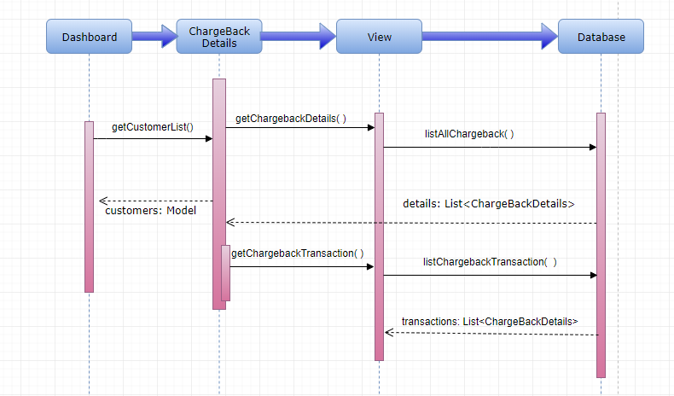

Business Rules
Business rules should be defined using the following attributes: -

- A registered Bank Representative user – is able to see the customers’ list whose chargeback are applicable.

UI Requirements
Here is a prototype on how the homepage should look like.

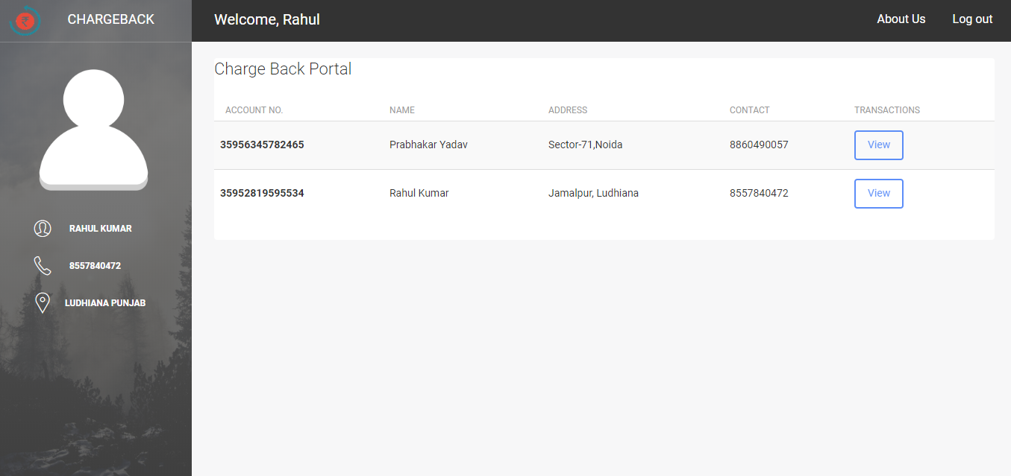

Use case ‘Edit Chargeback’

Use case attributes
Use Case Description:

This use case deals with the edit of the chargeback details. The ‘Bank Representative user’ here shall be the operator of the system and will be keying in the changes regarding chargeback to the system.

Scope:

- Edit Chargeback details to the database

Actors:

- Bank Representative User – the operator

Trigger:

Click ‘Edit’ button in Chargeback Details Page

Pre-Condition:

Bank Representative User being able to edit Chargeback Details upon click of ‘Edit’ button.

Post Condition:

Bank Representative User is in Edit chargeback form page & submit any changes in Chargeback details.

Flow of Events:

Bank Representative User at Chargeback Details page → Click ‘View’ button → Click edit button of particular transaction → Bank Representative user is at Edit Chargeback page with details pre filled and user is update any changes on submit button.

Use Case Model
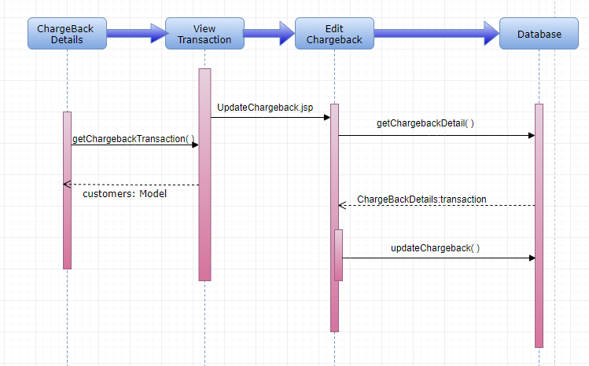

Business Rules

Business rules should be defined using the following attributes: -

- When the user clicks on the Edit chargeback button, it should re-direct to Edit Chargeback form.
- Clicking ‘Submit’ should validate the datatype constraints for each field
- Post-successful field level validation, save the information in the database

UI Requirements
Here is a prototype on how the homepage should look like.

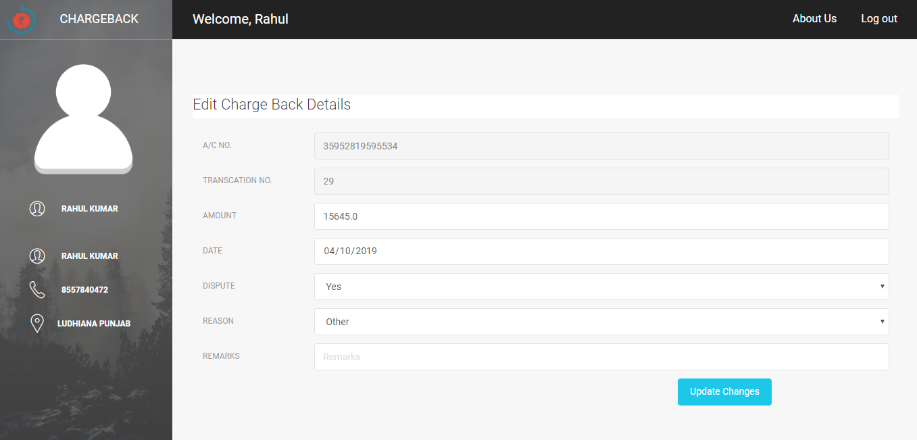

UI Field Validations
Please refer to the below requirements for field level validations:

- All fields are mandatory.
- Transaction Id is auto generated.
- Remarks mandatory if “Others” is chosen as reason attribute value.
- Invalid fields must be marked in red with alert message.

Use case ‘Refund for Chargeback’

Use case attributes
Use Case Description:

This use case deals with the refund of the chargeback of particular transaction. The ‘Bank Representative user’ here shall be the operator of the system and will be keying in the refund details with its status and comments.

Scope:

- Start refund process of chargeback and save its details in database

Actors:

- Bank Representative User – the operator

Trigger:

Click ‘Refund’ button besides required transaction.

Pre-Condition:

Bank Representative User being able to view transactions of particular account holder.

Post Condition:

Bank Representative User is refund details page post clicking refund button.

Flow of Events:

Bank Representative User at transactions page with chargeback details → Click ‘Refund’ button → Bank Representative user is at Refund detail page with details to be filled .

Use Case Model
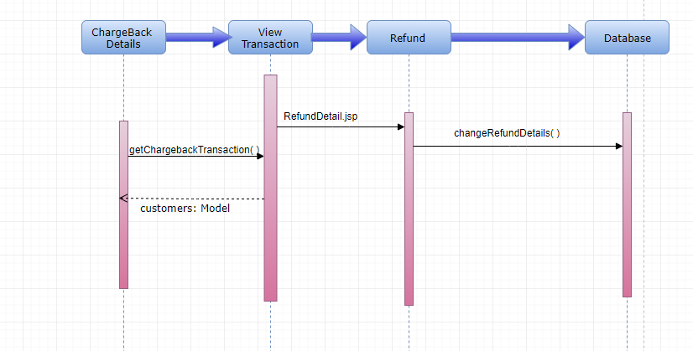

Business Rules

Business rules should be defined using the following attributes: -

- When the user clicks on the Refund button, it should re-direct to Refund Chargeback form.
    - User needs to fill some of the attributes/fields as mentioned below in requirement: Refund Status and Comments
- Clicking ‘Submit’ should validate the datatype constraints for each field
- Post-successful field level validation, save the information in the database.

UI Requirements
Here is a prototype on how the homepage should look like.

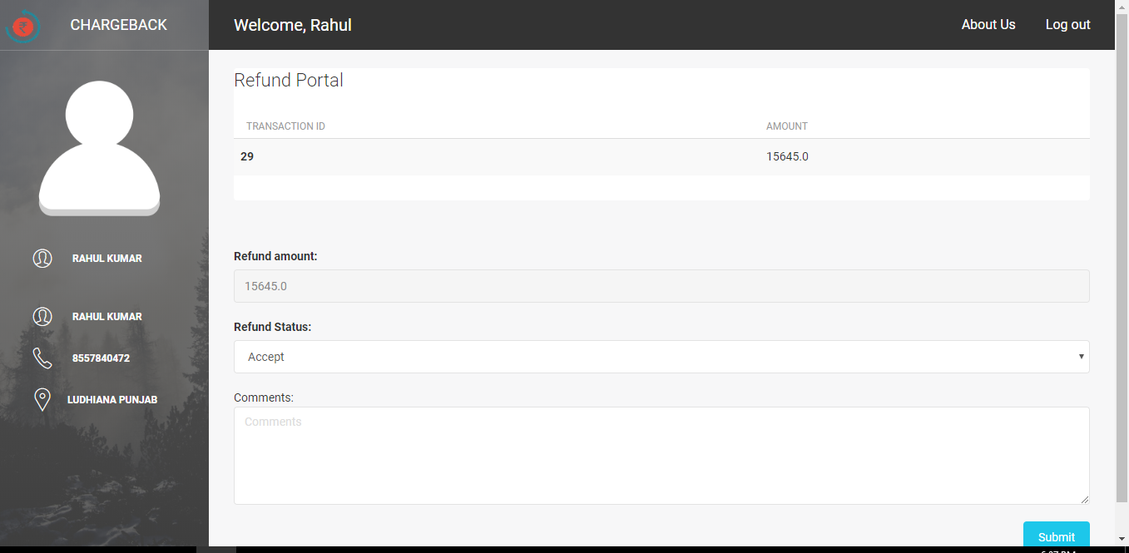

UI Field Validations
Please refer to the below requirements for field level validations:

- All fields are mandatory.
- Transaction Id is auto generated.
- Remarks mandatory if “Others” is chosen as reason attribute value.
- Invalid fields must be marked in red with alert message.

Use case ‘Send Notification’

Use case attributes
Use Case Description:

This use case deals with the send notification to user contact details of chargeback related to particular transaction. The ‘Bank Representative user’ here shall be the operator of the system and will be keying in the refund details with its status and comments.

Scope:

- Send refund notification to user and save its details in database

Actors:

- Bank Representative User – the operator

Trigger:

Click ‘Submit’ button.

Pre-Condition:

Bank Representative User being able to view refund form.

Post Condition:

Bank Representative User is refund details page post clicking refund button.

Flow of Events:

Bank Representative User at transactions page with chargeback details → Click ‘Refund’ button → Bank Representative user is at Refund detail page with details to be filled .

Use Case Model
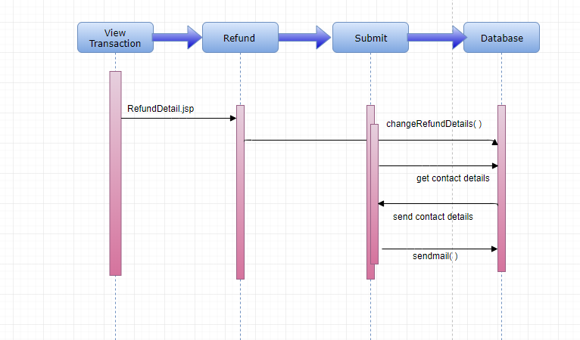

Business Rules

Business rules should be defined using the following attributes: -

- When the user clicks on the Refund button, it should re-direct to Refund Chargeback form.
- Clicking ‘Submit’ should validate the datatype constraints for each field
- Post-successful field level validation, save the information in the database and send notification to contact information (phone number or email address) about refund.

Database Design

Tables Structure
Bank Representative Registration:
Column Name | Data Type | Length | Nulls
User Id | varchar | 50 | N
Password | varchar | 50 | N
First Name | varchar | 50 | N
Last Name | varchar | 50 | N
Age | int | 2 | N
Gender | varchar | 10 | N
Contact Number | varchar | 10 | N
City | nvarchar | 50 | N
State | nvarchar | 50 | N

Bank Representative User login:
Column Name | Data Type | Length | Nulls
User Id | varchar | 50 | N
Password | varchar | 50 | N

Customer Details:
Column Name | Data Type | Length | Nulls
Account Number | varchar | 10 | N
Address | nvarchar | 50 | N
Contact | nvarchar | 50 | N
Name | date |  | N
Email Address | nvarchar | 50 | Y

Chargeback Details:
Column Name | Data Type | Length | Nulls
Account Number | bigint | 20 | N
t_id | bigint | 20 | N
Amount | float |  | N
Date | date |  | N
Dispute | nvarchar | 11 | N
Reason | nvarchar | 255 | N
Remarks | nvarchar | 255 | N

Refund Details:
Column Name | Data Type | Length | Nulls
Refund_id | bigint | 20 | N
comments | nvarchar | 255 | N
refundAmount | float |  | N
refundStatus | int | 11 | N
t_id | Bigint | 20 | N

Change Log
Version Number | Changes Made
V1.0 | Initial baseline created on <11-Mar-2019> by <Rahul Kumar>
V1.1 | <Please refer the configuration control tool / change item status form if the details of changes are maintained separately. If not, the template given below needs to be followed>
V1.1 | Section No. | Changed By | Effective Date | Changes Effected

